Unit 2 - Algebra

Section 2.0: Algebra Basics

Concept 1: Variables
In statistics, we defined the notion of a variable.
Variable (Statistics) – A property of the individual (that varies from one individual to another).
In algebra, we are also interested in variables. We use the term in several related ways.
A variable is a real-world ___________________ whose value is unknown or not specified.
Example Let x represent the number of seats on a bus.
A variable is the ___________________ that we use to represent some quantity.
Example The equation $y=2x-1$ contains ______ variables (______ and ______), each of which appears ______ time.
Example The equation $3x-4=2x+3$ contains ______ variable (______) which appears ______ times.
Example The formula $I=Prt$ (the simple interest formula) contains ______ variables, which represent:
I -
P -
r -
t -
Notice that, when a variable has a real-world context, we need two pieces of information to say what it represents:
- The ______________ that the variable represents
- What _____________________ that thing will be measured in
This is because when we do algebra, we only work with _______________, but in real life, the meaning of a number depends on its __________________.
Example In the simple interest formula, $t=4$ means 4 _______________.
If we wanted to represent 4 months, we had to use $t=$ _________.

Concept 2: Expressions
An expression is the most basic unit we work with in algebra.
An expression is a sequence of symbols consisting of numbers, variables, and symbols for mathematical operations which represents a number.
An expression which contains one or more variables is a variable expression. An expression which contains only numbers and symbols for operations is a numeric expression or arithmetic expression.

Example
$3x-1$ is a expression with ______ variable.
${(-2)}^{3}+11$ is a expression.
When our variables are defined in context, we can interpret our expressions in context.
Example Let x represent the number of cookies in a package.
$3x$ represents

$2x+5$ represents

$\frac{x}{3}$ represents

We can represent the number of cookies in 4 packages if 3 cookies are removed
by writing

When we have a complicated expression, we may want to write a simpler equivalent. This process is called simplifying.
Two expressions are equivalent if they have the same value, no matter what number the variable represents.
When we simplify an expression, we write the simplest possible equivalent expression. It may be necessary to define the “simplest possible” form for more complicated types of expressions.

Example The expression $2x+3x$ is equivalent to the expression $5x$. (We can confirm that by seeing what number this represents for various values.
x | $$2x+3x$$ | $$5x$$
0
5
-3
12
Since it’s easier to write and evaluate, we say that $5x$ is _____________________ than $2x+3x$. If we rewrite $2x+3x$ as $5x$, we can say we have simplified the expression.
We have the following moves available to us to simplify expressions.
- Do arithmetic operations to combine numbers.
Example
- We can rewrite $3∙2x+3+5$ as
Think of this as

- Use the associative property to eliminate parentheses if we are only using addition or only using multiplication.
Example
- We can rewrite $\left(x+4\right)+1$ as
We can think of this as

- We can use the distributive property to eliminate parentheses when multiplication and addition are mixed.
Example
- We can rewrite $3(x+1)$ as
Think of this as

- We can combine like terms to decrease the number of variable terms.
Examples
- We can rewrite $3x+5+2x$ as
Think of this as

- We can rewrite $5x-2-3x+4$ as
Think of this as

When we evaluate (work out the value of) expressions, we must be aware of order of operations. It’s possible to over-think order of operations, but the key ideas are:
- Exponents come before multiplication.
- Multiplication comes before addition.
- If we want to violate this order, we use grouping symbols (parentheses, fraction bars).
Notice that we didn’t mention ____________________ or ____________________. That’s because these aren’t “real” operations.
- Division is really just : $6÷3$ is $6∙$ ________
- Subtraction is really just : $5-2$ is $5+$ ________
In algebra, we almost never write ___________________ without using a fraction bar.
Example Evaluate $3∙{\left(-2\right)}^{2}+5∙\left(-2\right)-7$

If we have a _________________ expression, we must know what number the variable(s) represent before we can evaluate.
Example Evaluate $3x-7y+4$ when $x=5$ and $y=2$.

Concept 3: Equations
The most common object to work with in an algebra class is an equation.
An equation is a statement that two (or more) expressions are equal, that is, they represent the same number.

Example
- The equation $2+3=5$ says that the expressions _____________ and ________ are equal.
- The equation $2x+3=11$ says that the expressions _____________ and ________ are equal.
- The equation $y=\frac{1}{2}x-4$ says that the expressions _____________ and _____________ are equal.
- The equation $\frac{3}{4}=0.75=75\%$ says that the expressions ________, ________, and ________ are all equal to each other.
- The equation $I=Prt$ says that the expressions ________ and _____________ are equal.

As the above examples show, we use equations in several ways.
- To show the ________________________ of arithmetic.
- To place a ___________________________ on an unknown number.
- To show a ___________________________ between two unknown numbers.
- To show that a _________________________ can be expressed in different ways.
- To show a ________________________ between real-world quantities.

The simplest equations in algebra are linear equations in one variable.
An expression or equation is linear if the only operations that appear are addition (and subtraction) or multiplication (and division) by numbers. If variables are multiplied together, variables are divided by, powers of variables are taken, or variables appear in exponents, the expression or equation is not linear, or non-linear.
The number of variables in an expression or equation is the number of different variable symbols that appear. The same variable can appear more than once without changing the number of variables.

Examples:
- $2x+3$ is a
- $4x-5y$ is a
- $3x+1=2x-7$ is a
- $4x-3y=12$ is a
- $x^{2}+1$ is a
- $y=0.2x^{2}-7x+4$ is a
- $2^{x}-4$ is a

One of the things we will want to do, especially with equations in one variable, is to solve them.
A solution to an equation is value(s) of the variable(s) that make the equation true, that is, makes the expressions equal.
To solve an equation means to find all possible solutions.

Example
- $x=4$ is a solution to the equation $3x-5=7$ because

- $x=1$ is a solution to the equation $2x^{2}-5x+4=1$ because

- $x=3$ is a solution to the equation $3^{x}=5x+12$because

We will often use ________________________ to solve equations.

Concept 4 – Solving a Linear Equation in One Variable
We have three basic moves available to us to solve equations. (There are more advanced moves that you would learn if you took an advanced algebra class.)
- Simplify the ___________________________ on each side of the equation.
- Add or subtract the same
on both sides of the equation.
- Multiply or divide by the same _____________________ (but not ___________) on both sides of the equation.
When we use any of these moves, we get an equivalent equation.
Two equations are equivalent if they have exactly the same solutions.
Example The equations $2x+3=7$ and $3x-1=5$ are equivalent, because both have $x=2$ as their only solution.

Here’s how we’ll apply these three moves to solve any equation.

One-step equations
A one-step equation is one in which the variable appears only once, and only one operation is applied to it. To solve, we’ll do the opposite of that operation.
Example Solve $x+5=11$.
Here, ________ is being __________ to x. The opposite of
is ___________________________.

Example Solve $\frac{2}{3}x=10$
Here, x is being _____________ by _______. The opposite of
is ___________________________.

Two-step equations
A two-step equation is one in which the variable appears only once, but both multiplication and addition (or subtraction) are applied to it, without parentheses. To solve, we’ll reverse first the _________________ then the _________________.
Example Solve $4x-7=9$
First, we on both sides.

Then, we on both sides.

The solution is $x=$ ______

Equations with variables on both sides
When the variable appears on both sides of the equation, we first ___________________ or __________________ to eliminate one of the variable terms.
Example Solve $5x+4=2x-5$
First, we subtract ___________ on both side, and .

Now we have a !
Next, we on both sides.

Finally, we on both sides.

Equations that don’t look like any of those
If we have a linear equation, it’s always of one of these types. But we may need to simplify or otherwise rewrite the equation to be able to see it.
Example $29-x=11$

Example $12+5\left(x-1\right)+4=26$

Concept 5 – Finding Solutions to an Equation in Two Variables
An equation in two variables needs ______ numbers to have a solution: one number for each ____________________.

In general, equations in two variables will have solutions.

To find a solution to an equation in two variables:
- Choose a __________________ for one _________________ and plug it in.
- You now have an equation in _____________________ variable!
- __________________ the new equation.
- Answer as an ordered pair.
Example Find a solution to the equation $y=2x-1$
We see that this will be easier if we pick a value for _____ and find the value of _____.

One solution is ________________________________.
Note: in the ordered pair, the first number represents the value of _____ and the second the value of _____. If our variables are x and y, they will always be in this order.
To make the order clear, we could write

Example Find three different solutions to the equation $y=\frac{2}{3}x+5$, at least one by choosing a value of y.
First solution: choose ___________________________.

Second solution: choose ___________________________.

Third solution: choose ___________________________.

The three solutions we found are:

Concept 6 – Coordinate Planes
We can represent a single variable as a point on a number line.
Example Graph $x=2$ on the number line below.
Graphing gets more interesting when we are interested in two variables.
To graph two variables, we draw two number lines at right angles to each other, called axes. They are labeled with numbers and with variable names.
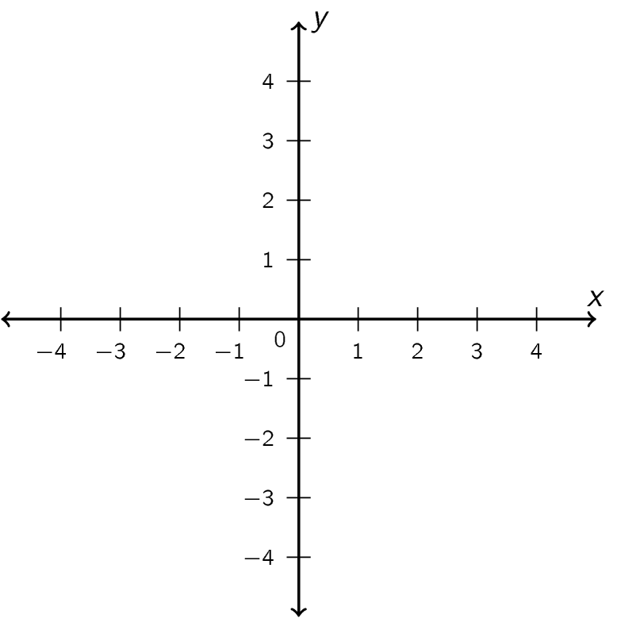
This is called a coordinate plane. Each point on such a plane represents a pair of values. For example, the point marked below represents the pair $x=2$, $y=-3$. We can also write this as the ordered pair $(-2,3)$. When we’re graphing, the first number always represents the number shown on the horizontal axis, the second on the vertical axis.
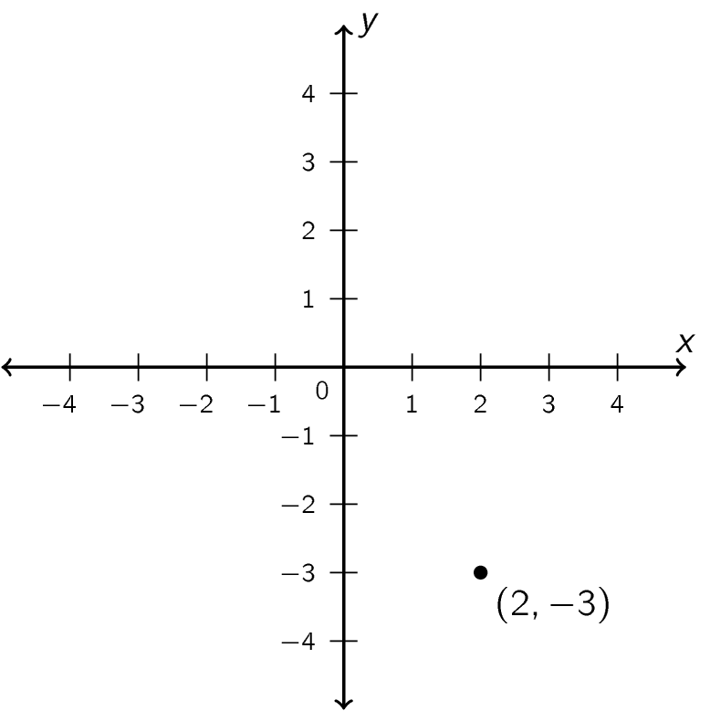
In order to make a coordinate plane easier to read, we often include a grid. In our grid, each vertical line represents points with the same x-coordinate (that is, at the same horizontal distance), and each horizontal line represents points with the same y-coordinate (that is, at the same horizontal distance). Notice which lines the point $(-2,3)$ lands on.
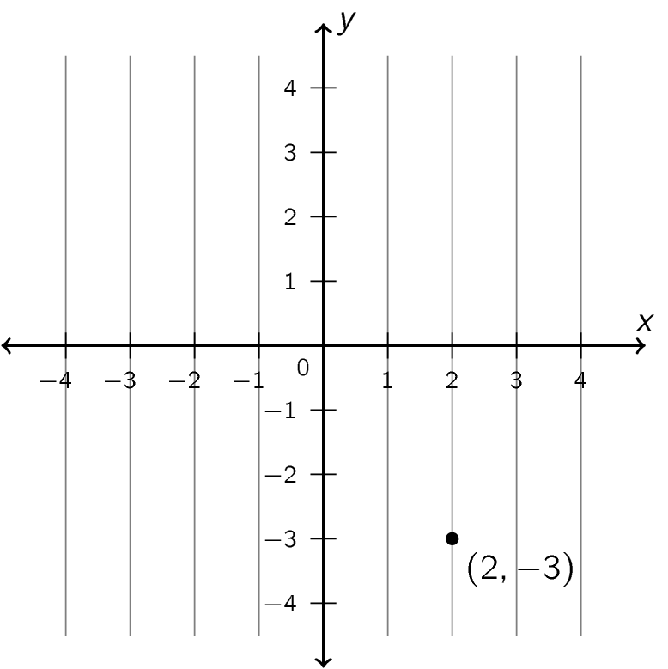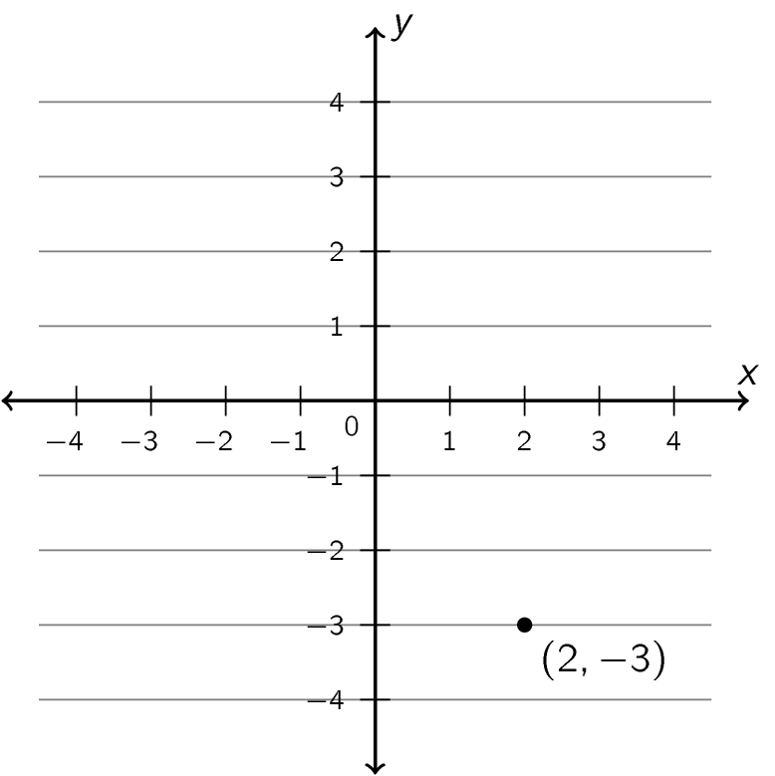
Vertical line labeled with Horizontal line labeled with
the ____ coordinate the ____ coordinate
If we want to “plot” a point on a coordinate plane, then, we use the labels on the horizontal and vertical grid lines.
Example Plot the points $(4,1)$, $(-2,3)$, and $(0,-2)$ on the axes below.
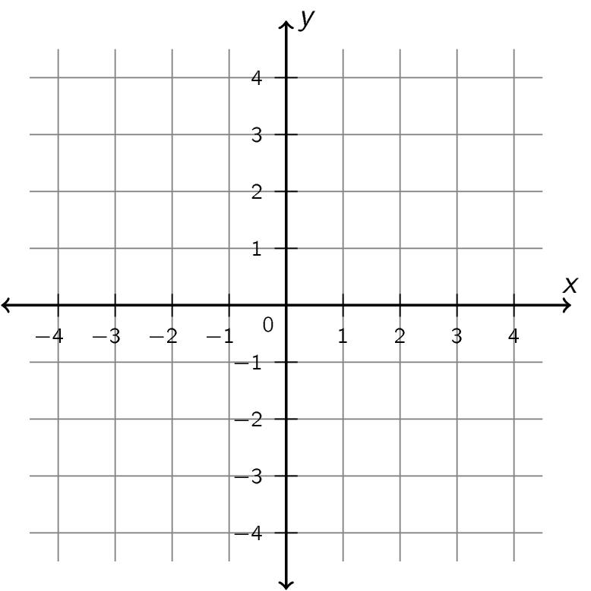
We don’t need to count by 1s when we label axes. We can give fractional labels, or skip count. It is important to look at the numbers used to label the axes, not just to count spaces.
Example Label the points on the graph below with their coordinates.
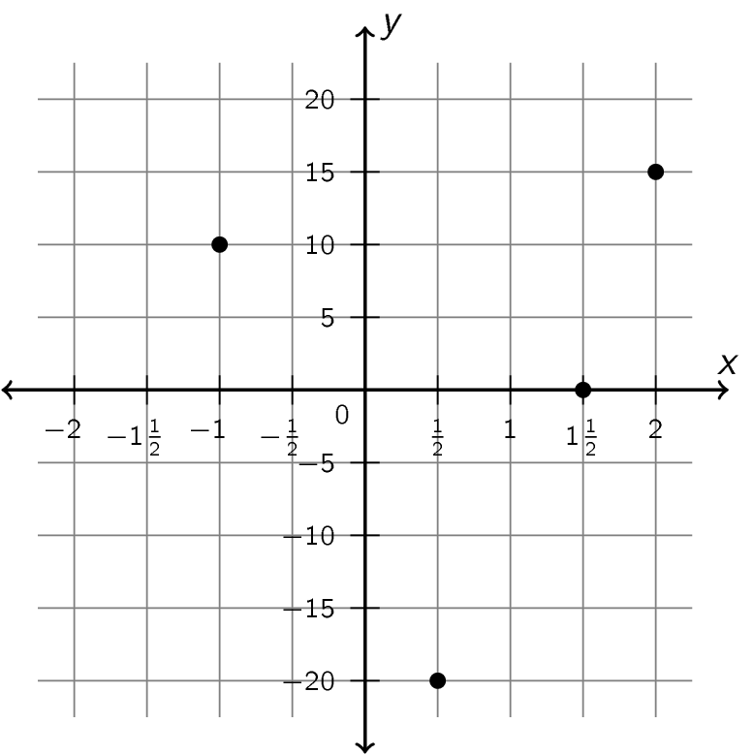
Note: While the x-axis may have different spacing than the y-axis, each axis should have the same spacing all along its length.

Concept 7 – Graph of a Linear Equation
We can use a coordinate plane to graph an equation in two variables. The graph consists of all the pairs of values that are solutions to the equation.
Example The graph below is the graph of the equation $y=\frac{1}{2}x-1$. Choose some points on the graph and observe that their coordinates are solutions to the equation.
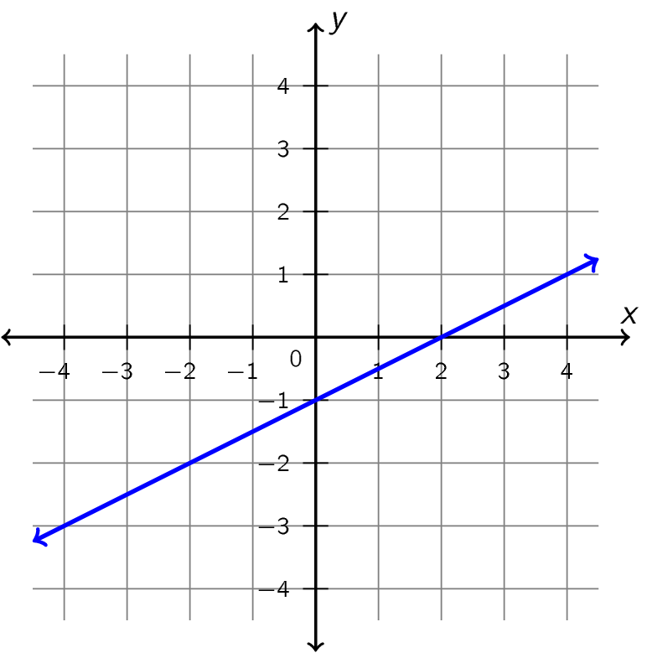
From geometry, we know that it takes two points to “fix” a line: that is, if we know two points, there is only one line that we can draw through them. That means that if we want to draw the graph of an equation in two variables, we need to know two points on the line.
Example Find two solutions to the equation $3x+2y=12$. Use them to sketch the graph of this equation.

First solution:

Second solution:

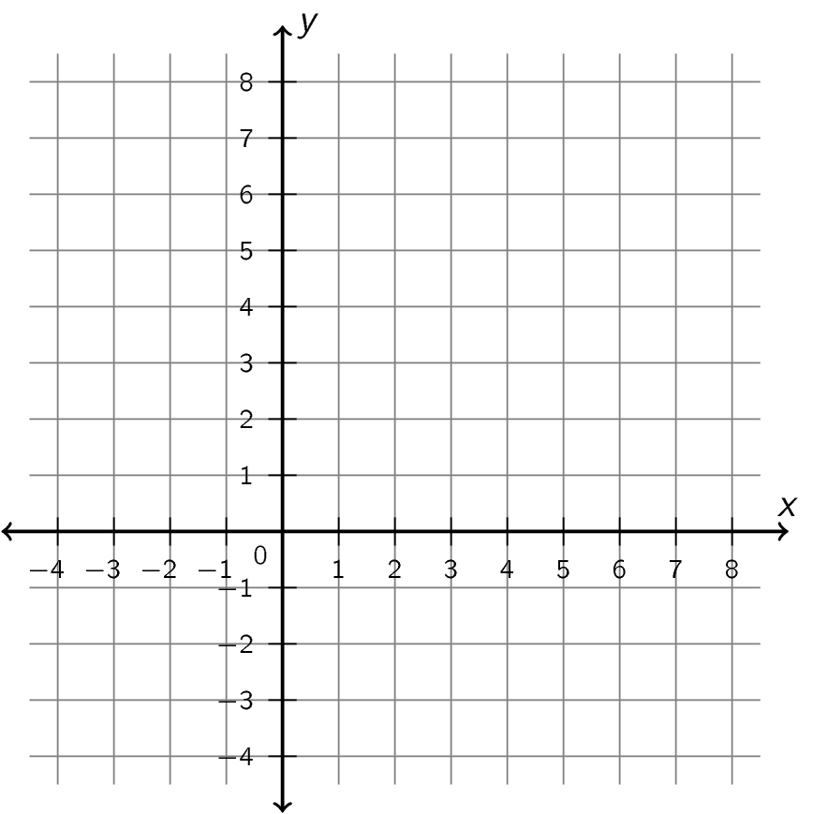

This method can be difficult, because we often get fractions when we try to find solutions to an equation in two variables. When a linear equation in two variables is given in a certain specialized form, we have a simpler method of graphing the equation.
Slope-Intercept Form of an Equation
A linear equation in two variables is in slope-intercept form if it is written as
$$y=mx+b$$
where m and b are numbers. The number m is called the slope of the line, and the number b is called the intercept.

Example The equation $y=2x-3$ is in slope-intercept form.

- Identify the slope and the intercept from the equation.
Slope: ______
Intercept: ______
- Fill in the table below with solutions of the equation.
x | y | Work
−2
−1
0
1
2
- Using two of the solutions in the table, draw a graph of the equation.
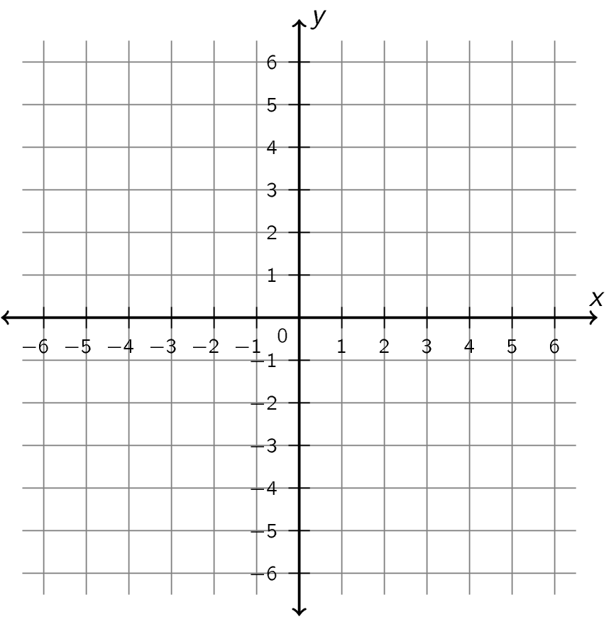

- Where do we see the slope and the intercept in the graph?
The slope is

The intercept is

Example The equation $y=-\frac{3}{2}x+1$ is in slope-intercept form.

- Identify the slope and the intercept from the equation.
Slope: ______
Intercept: ______
- Fill in the table below with solutions of the equation.
x | y | Work
−4
−3
−2
−1
0
1
2
3
4
- Using two of the solutions in the table, draw a graph of the equation.


- Where do we see the slope and the intercept in the graph?
The slope is

The intercept is

This gives us a method of drawing the graph of an equation given in slope-intercept form without actually finding solutions to the equation. (Notice that this method is just a shortcut to using the tables above!)
- Find the intercept on the y-axis. (This point is the y-intercept of the line.)
- Find the denominator of the slope. If the slope isn’t a fraction, its denominator is 1. Starting from the y-intercept, count that many spaces to the right.
- Find the numerator of the slope. If the slope is positive, count that many spaces up. If the slope is negative, count that many spaces down.
Example Use the shortcut to sketch the graph of $y=\frac{3}{4}x-2$

Example Use the shortcut to sketch the graph of $y=-2x+5$


The kinds of lines we have graphed so far are called “oblique” lines. We can also graph a horizontal or a vertical line.
The graph below shows a horizontal line and a vertical line.

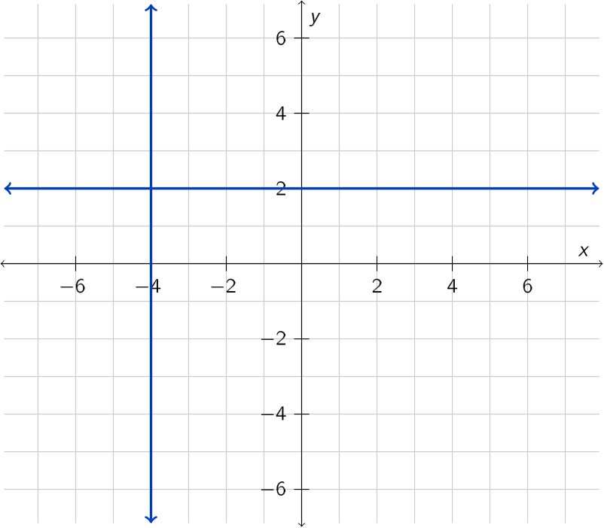

- The points on the vertical line all have the same
The equation of this line is
- The points on the horizontal line all have the same
The equation of this line is
EQUATIONS FOR HORIZONTAL AND VERTICAL LINES
The graph of $y=b$ where b is a constant is a ______________ line.
The graph of $x=a$ where a is a constant is a ______________ line.

